# The Algorithm

For our dynamic programming algorithm to solve this problem, we will need two m×m 2-dimensional arrays, of which we will only use one half.

|  |  |  |  |  |
| --- | --- | --- | --- | --- |
|  |  |  |  |  |
|  |  |  |  |  |
|  |  |  |  |  |
|  |  |  |  |  |
|  |  |  |  |  |

One of them is called M, which stores the minimum runtimes; the other is called S, which stores the multiplication orders.

Each matrix sequence multiplication can be broken down into a multiplication of two sequences. For example,

A1 ((A2 A3) A4)

can be broken down into the multiplication of the length one sequence A1 and the length 3 sequence ((A2 A3) A4). ((A2 A3) A4) can in turn be turned into the multiplication of (A2 A3) and A4. (A2 A3) at last will be the multiplication of two length one sequences A2 and A3.

We formulate our problem of multiplying a sequence of matrices starting at matrix i and ending at matrix j as

Opt(i, j)

. Opt(3, 6) means the optimal runtime and corresponding order of multiplying the sequence from matrix 3 to matrix 6. We want Opt(1,m) for this problem.

The rows of our two 2-dimensional arrays specify the starting matrix, the column specifies the ending matrix (e.g. M[3,6] is the least runtime possible for multiplying the sequence starting at matrix 3 and ending at matrix 6; S[3,6] is the corresponding optimal order of multiplication). We want M[1,m] and S[1,m] for this problem.

## Pseudocode

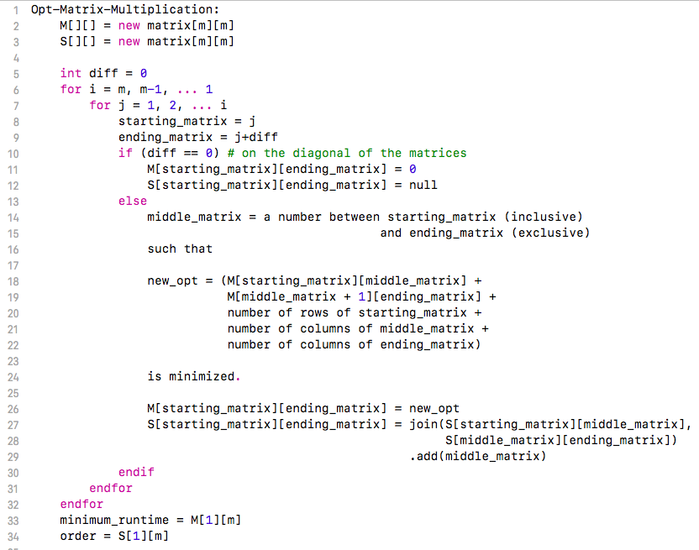

This part

for i = m, m-1, ... 1

for j = 1, 2, ... i

…….

graphically represented is this:

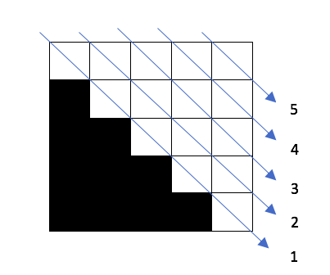

# Proof of Correctness

Observe that the optimal multiplication ordering of a sequence of matrices of length > 1 is broken into two sequences at an optimal spot. Call the last matrix of the first sequence the middle matrix. A sequence of length three can be broken down into

A1 (A2 A3)

or

(A1 A2) A3

.

And (A1 A2) is broken down into the multiplication of single matrices A1 and A2. Opt(a single matrix A1) = A1, which is the base case. Each of the two optimally broken sequences can in turn be broken into their own optimal two sequences. Done recursively, this looks like a tree. The runtime of multiplying the two sequences is the sum of the runtimes from each sequence plus the runtime of multiplying these two sequences, which is the product of the number of rows of the starting matrix and the number of columns of the middle matrix and the number of columns of the ending matrix. The recursion can be summarized as

$$Opt\left({matrix}_{start}, {matrix}_{end}\right)$$

$$=\left\{\begin{aligned}0, if matrix_{end}=matrix_{end} \\ .{\begin{aligned}min \\ matrix_{start}≤ matrix_{middle}<matrix_{end}\end{aligned}}\left(\begin{aligned}Opt\left(matrix_{start}, matrix_{middle}\right)+ \\ Opt\left(matrix_{middle}+1, matrix_{end}\right)+ \\ number of rows of matrix_{start}* \\ number of columns of matrix_{middle}* \\ number of columns of matrix_{end}\end{aligned}\right)\end{aligned}\right.$$